# Test Document for Modification in report Payment Details IR Wise

Testing for given data.

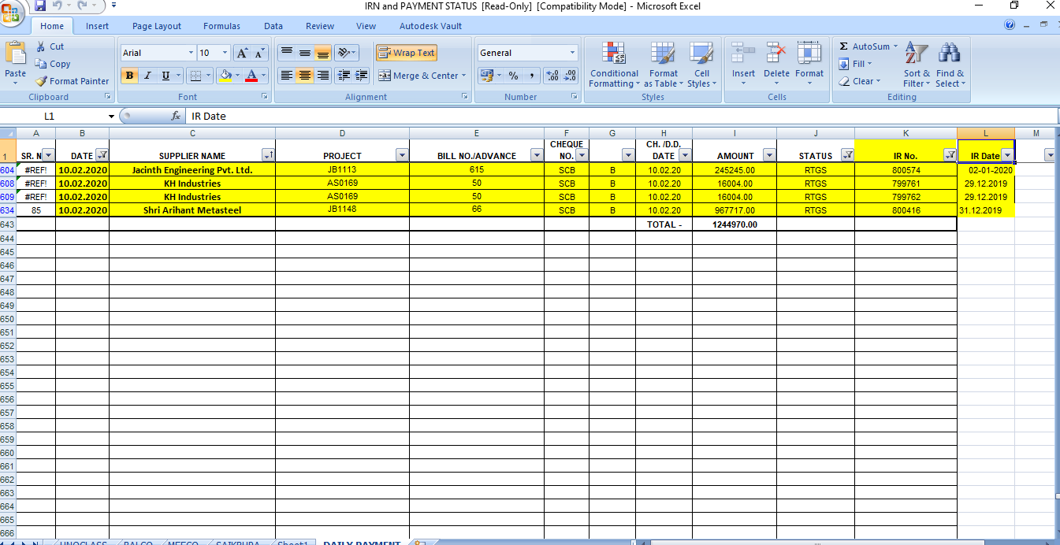

After bug fixing in report, testing for 800574

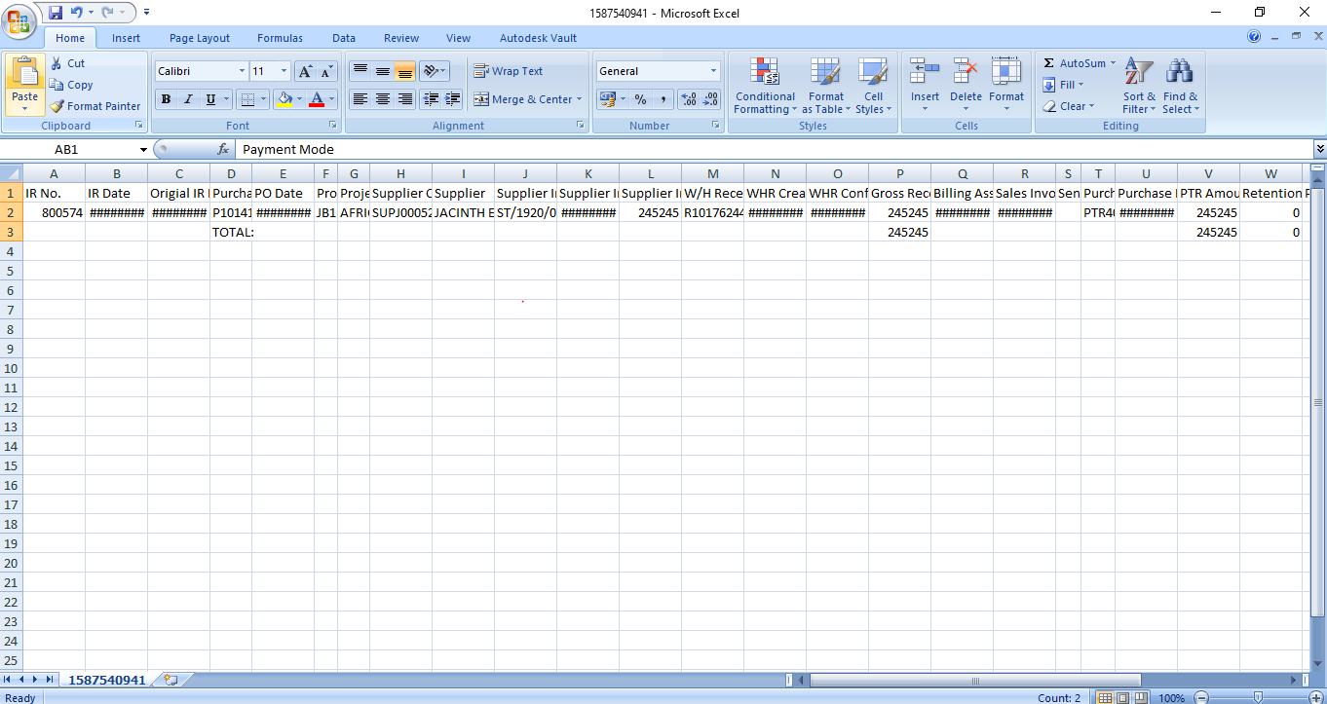

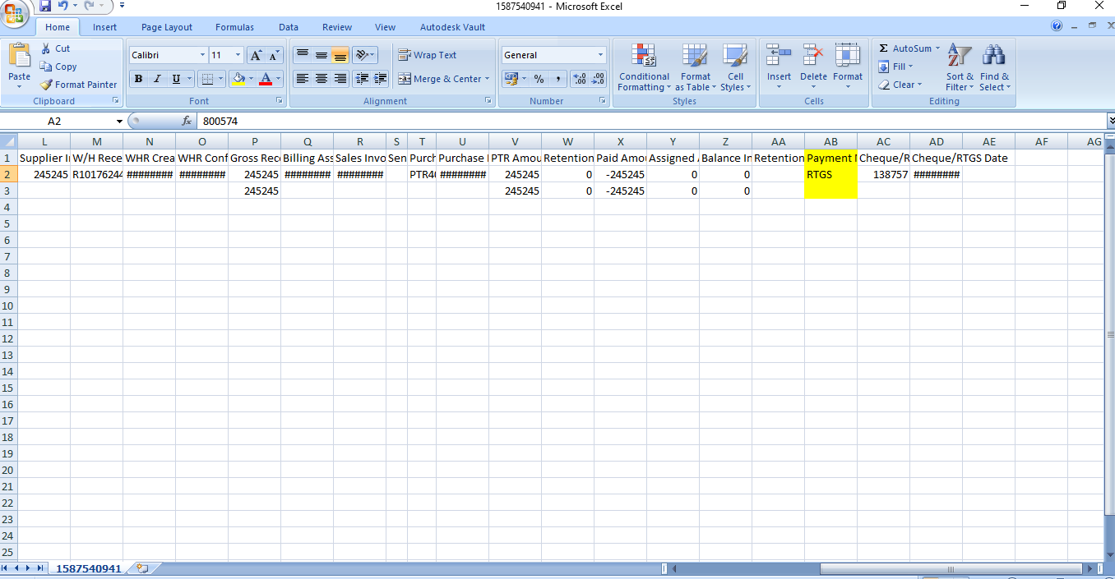

RTGS are comes on it.